Student Names: Muhammad Naveed 4384 Instructor: Muhammad Ejaz
Lab Task No 5
#task 1 def final_price(price, tax_percentage):
tax_amount = price * (tax_percentage / 100) return price + tax_amount print(final_price(1000, 5))

#task 2 def factorial(n): result = 1 for i in range(1, n + 1):
result *= i return result num = int(input("Enter a number: ")) print("Factorial is:", factorial(num))

#task 3 def temperature_status(temp): if temp < 10: return "cold" elif 10 <= temp <= 25:
return "warm" else:
return "hot"

temp = float(input("Enter temperature in Celsius: ")) print("Weather is:", temperature_status(temp))

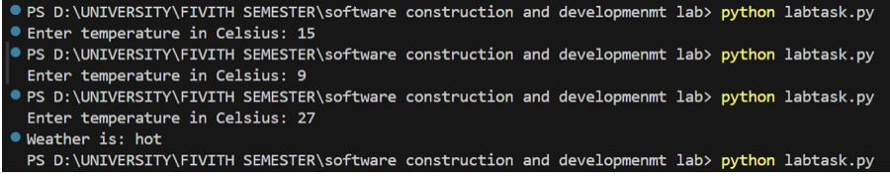
#task 4

def calculate(a, b): sum = a + b difference = a - b product = a * b return sum, difference, product

num1 = int(input("Enter first number: ")) num2 = int(input("Enter second number: "))

sum, dif, prod = calculate(num1, num2)

print("Sum:", sum) print("Difference:", dif) print("Product:", prod)

#task 5 def sum_list(numbers):
total = 0 for num in numbers:
total += num return total

user_input = input("Enter numbers : ") num_list = [int(x) for x in user_input.split()]

print("Sum of the list is:", sum_list(num_list))

